NUnit
Unit Testing Calculator Operations

CalcLibrary / Calc.cs

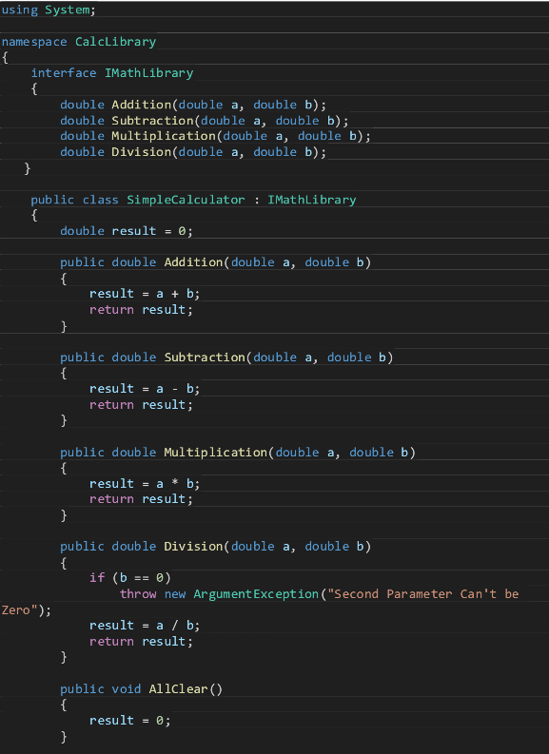
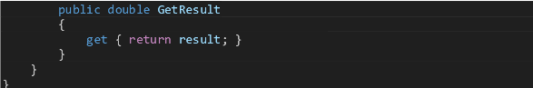

CalcLibray.Tests / CalculatorTests.cs

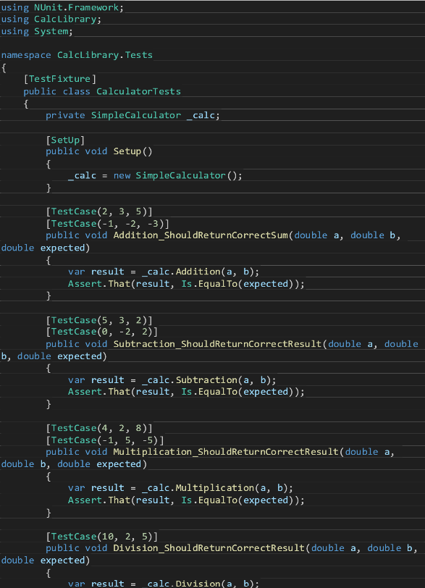
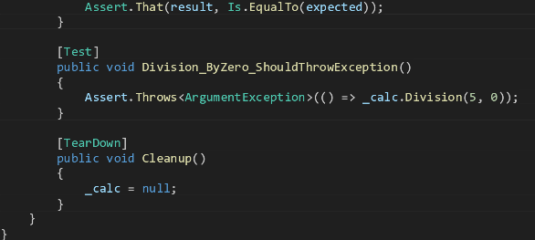

Output:

